**Case Study Three  
Photography & Fiction Workshop**

#### Background

The Photography & Fiction Workshop was part of the BA Photography First Year curriculum. Students had the opportunity to self-select this workshop from a set of four options. It was situated within the Photographic Fictions unit, a course that primarily focuses on the production, design, and printing of a photo book, rather than fiction. Despite the misleading name, the unit builds on skills learned in earlier modules such as *Introduction to Photography* and *Remix, Remake*, and is typically well-received by students.

I delivered this workshop twice in one afternoon for two different groups. The focus of the session was on the intersection of photography and creative writing, which was designed to engage students with the idea of writing in response to visual prompts. The workshop used a series of photographs provided by Kalpesh Lathigra, a fellow PGCert student, to inspire creative writing exercises. These exercises aimed to encourage students to respond imaginatively to images and develop their written expression. The broader goal was to foster a relationship with reading and writing, which is often underdeveloped in students focused on the visual arts.

The workshop’s motivation was further inspired by a recent YouGov poll, which revealed that 40% of Britons have not read or listened to a book in the past year (Flood, 2025). This statistic underscored the importance of encouraging reading and writing in a creative context, especially for young adults.

*Figure 1 – slide from workshop*

#### Evaluation

The first session began with a short reading of a fiction piece by Kathryn Scanlan, published in *Granta Magazine*. This provided a foundation for discussing the role of photo-editing in relation to storytelling and the importance of reading as a form of research. The discussion emphasised how fiction can inform photographic practices, particularly when it comes to creating narrative-driven images. We also explored how audio-books serve as an alternative means of engaging with literature.

While I have extensive experience combining text and image in my personal practice, I was less familiar with teaching creative writing. This made the session both challenging and rewarding, as it pushed me beyond my comfort zone of teaching more practical, technical modules. However, asking students to respond to images with short pieces of creative writing proved to be a dynamic and engaging approach, highlighting the versatility of photographers in engaging with textual storytelling.

The second session, delivered later in the day, had a different energy. The students appeared more fatigued, likely due to the accumulation of classes throughout the day. To adapt to this, I adjusted my teaching strategy by encouraging more verbal responses and facilitating group discussions on the first few slides. This approach allowed students to still engage with the task, despite the tiredness that set in.

From this session, I learned a lot about the importance of adaptability in teaching. Tailoring the delivery to the group’s energy levels helped maintain engagement and fostered a collaborative atmosphere.

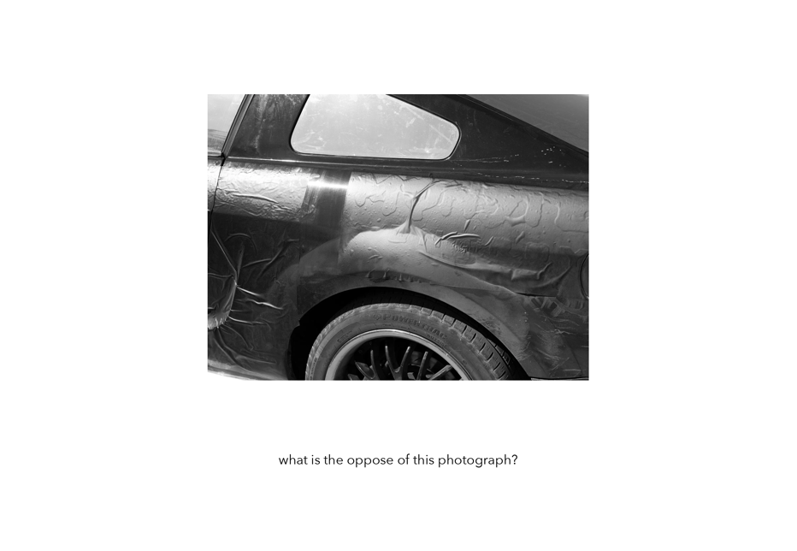

*Figure 2 – slide from workshop*

#### Moving Forward: Implications and Actions

Reflecting on these two workshop deliveries, I recognize several key areas for improvement and future action:

1. **Strengthening Reading Habits:** Given the statistics from the YouGov poll, it is clear that fostering a habit of reading is crucial for students' development. I plan to explore further ways to integrate reading into creative practice, perhaps by assigning reading materials related to photography and fiction, or even encouraging students to listen to audiobooks.
2. **Balancing Writing and Visual Practice:** While the workshop successfully integrated writing with photography, I recognize that more structured guidance may be needed for students who struggle with writing. For future iterations, I plan to offer more scaffolding exercises, such as providing clearer prompts or examples of how writing can enhance photographic storytelling.

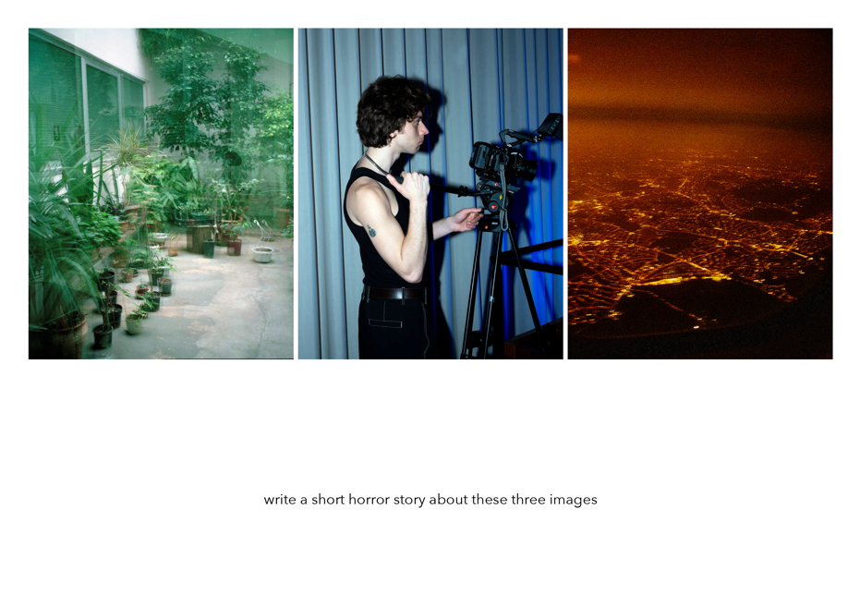

*Figure 3 – slide from workshop*

To commit to these next steps, I will create a more detailed action plan for the next session, which will include the introduction of more interactive elements and clearer writing prompts. Additionally, I will consider revisiting the materials to introduce more structured reading elements for the students.

#### **Sources**

Flood, A. (2025) 'New poll finds 40% of Britons have not read a book in the past year', *The Guardian*, 6 March. Available at:<https://www.theguardian.com/books/2025/mar/06/new-poll-finds-40-of-britons-have-not-read-a-book-in-the-past-year> (Accessed: 15 March 2025).