Case Study One
Hot Potato Industry Brief in BA Photography 1st Year

Background
The Introduction to Photography unit is the first module that BA Photography students encounter. Traditionally, this unit focused heavily on technical skills, with less emphasis on creativity. This academic year, I took over as the unit lead, having previously taught on it.
I strongly believe in integrating industry experience into the classroom. Despite this being an introductory unit, we decided it was not too early to introduce an industry-set brief. Working closely with Naoise O’Keefe, Editor of Hot Potato, we developed an engaging and accessible brief designed to foster creativity while building essential skills for future units. The brief, which was developed in collaboration with the course team, is attached.
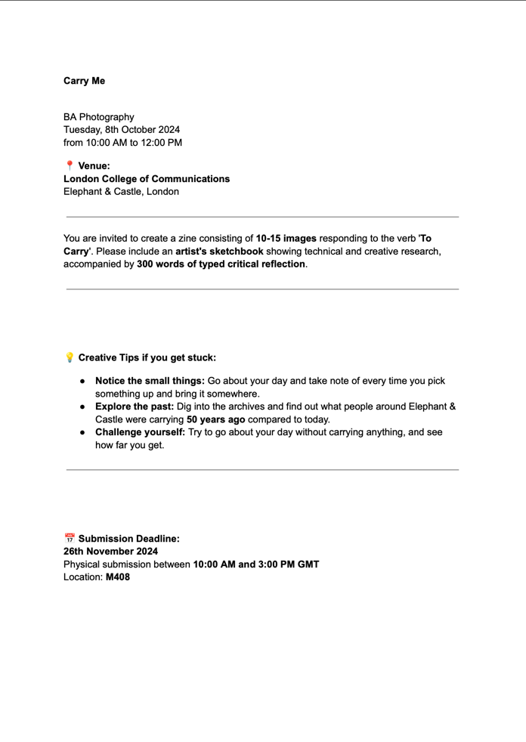
Figure 1 – Industry Brief

Evaluation
Restructuring an entire unit is always challenging, but collaborating with an industry partner brings significant benefits. Naoise and I introduced the brief at the start of the unit, and the teaching team delivered technical, practical, and theoretical sessions throughout. In the final week, Naoise returned to review the students' work and selected five winners, each representing a different category. This allowed for the students to receive summative feedback from an industry professional.
​​“...there is some evidence that reflective capacities can be fostered by providing students with strategies and experiences which develop the required metacognitive skills.”​
Hatton & Smith (1995)
Student feedback, collected anonymously across all Introduction to Photography units in the Media School, highlighted the positive impact of this approach:
“I really liked learning from someone in the industry and being given a brief to work on, as well as the mini workshops we were given weekly.”
“I would like 200 more words allowed in the critical analysis, and I really enjoyed the exhibition and working with someone from the industry.”

Personal Critique
While the new structure was well received, some students experienced confusion regarding the final zine format due to its open-ended nature. While many embraced the flexibility, ensuring clarity for all learners—particularly those who benefit from more structured guidance—is an area for improvement.

Specific Actions & Next Steps
To enhance the unit’s effectiveness for a diverse group of first-year students, I will implement the following improvements over the summer in preparation for next year’s delivery:
Clarify the zine framework in the unit brief by specifying the recommended size, page count, and image number. Students will have the option to follow this guidance or challenge themselves with more complex formats. Ensure that the unit brief is written with careful attention to clarity, making expectations explicit while allowing creative flexibility.

Sources
Hatton, N. & Smith, D. (1995). Reflection in teacher education: Towards definition and implementation. Teaching and Teacher Education, 11(1), pp.33-49.

